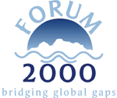
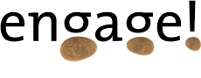

Strategies for Bridging Global Gaps

A report from the Forum 2000 Conference 2003

By Peter Merry

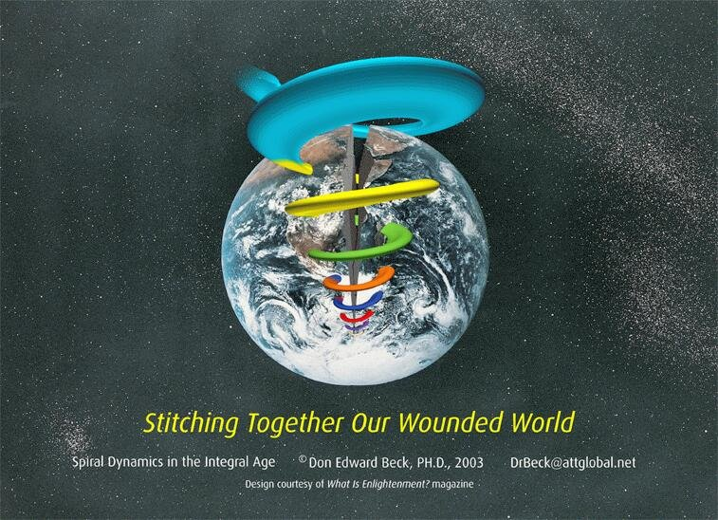
"No more prizes for forecasting the rain. Only prizes for building the arks." Don Beck

"One cannot merely follow the timetable we have set for our influence on the world, we must also honour and respect the infinitely more complex timetable the world has set for itself. That timetable is the sum of the thousands of independent timetables of an infinite number of natural, historical and human actions." Vaclav Havel

Table of Contents

Executive Summary 3
Introduction 4
Naming the Dilemmas 5
Issues 5
Liberalisation vs. Protection 5
Regulations vs. Own Responsibility 6
Industrialisation vs. environment 7
Valuing Global Public Goods vs. Skepticism of the Market 7
Change Dynamics 7
Old vs. New 7
Dialogue vs. Impact 8
Dynamics of Power 8
Need for global problem-solving fora vs. current power imbalances 8
National Identity vs. Transnational Governance 9
Promises vs. Implementation 9
Unmasking the Dynamics 10
The Spiral 10
Liberalisation vs. Protection 15
Regulation vs. Own Responsibility 18
Industrialisation vs. environment 19
Valuing Global Public Goods vs. Skepticism of the Market 20
The Dynamics of Change 20
Change States 21
Change Conditions 22
Change Variations 22
Old vs. New 23
Dialogue vs. Impact 24
Need for global problem-solving fora vs. current power imbalances 24
National Identity vs. Transnational Governance 25
Promises vs. Implementation 25
Taking it Forward 27
The space 27
The Perspective 28
The Focus 29
Conclusion 30
Bibliography 31

Spiral / Earth cover graphic used with kind permission of Dr Don Beck (drbeck@attglobal.net).

Executive Summary

This paper outlines dilemmas that emerged out of the Forum 2000 Bridging Global Gaps conference 2003, analyses the dilemmas in an integral framework, and makes suggestions for how the conference could be taken forward in the future. It also serves as a more general guide for those working with global problem-solving today.

The integral framework has as its goal to be able to find space for all sides of the dilemmas present, show how they relate to each other and could be transcended to move forward with global problem-solving. The different sides of the dilemmas are expressions of different perspectives active in the world today. These perspectives are bound up with the life conditions that people on the planet face.

Some of the perspectives are related to deep value systems which are active due to those varying life conditions. These value systems can be located on an evolutionary framework to show how they inter-relate. Other perspectives are tied up with dynamics of change that focus on global problem-solving triggers, including power relationships. This analysis draws particularly on the work of Don Beck and Ken Wilber.

The recommendations deal with the kind of space that is needed for global problem-solving, the integral perspective that enables one to consciously move ahead with all perspectives in the picture, and suggested focus for the content of the conferences. The space needs to be one which holds people together behind a common purpose, framed by collective principles which serve that purpose and ensure that people speak as world citizens for the common good, rather than from their own narrow agenda. This concept draws on the work of Dee Hock and Claus Otto Scharmer, and our experience at Engage! InterAct.

The suggested focus for the conferences includes bringing in insight around change dynamics, as well as picking a few inherently global issues and starting off global problem-solving processes for each issue, inspired by Jean-Francois Rischard's Global Issues Networks. Following an analysis of change conditions, it also suggests a focus on identifying current barriers to change, and on exploring what kind of consolidation systems might need to be in place to support this change.

The paper as a whole draws its inspiration from Vaclav Havel's insights on change (illustrated by two quotes in the paper), and Ken Wilber's integral vision for global governance. I trust this paper helps us to take another step in the right direction.

Introduction

In October 2003, the Forum 2000 Foundation organised its seventh conference, more recently entitled "Bridging Global Gaps". I was invited "to create an integral map based on evolutionary systems thinking which identifies how the ideas and institutions present at the Bridging Global Gaps conference 2003 relate to each other and our current global problems". Another element of the task was to observe the process at work, and make suggestions for how it could be developed to better reflect the kind of problem-solving processes that are needed to solve Inherently Global Issues (IGIs).

The objectives are to provide a report for the Bridging Global Gaps 2003 Conference which:
- presents an overview of how the different initiatives and institutions present at the Conference relate to each other in a developmental context
- identifies apparent flash-points and conflicts between initiatives and institutions, and plots them out on the integral map
- creates a framework which includes all the ideas and projects, and enables one to see them in a bigger context in relation to each other and the development of human society
- outlines a framework for the more conscious development of effective global governance
- develops a clearer picture of how to pull together a package and process that meets the needs of all

The report comprises of three main sections. The first names the dilemmas, identifying the paradoxes and tensions which surfaced at the conference. The second unmasks the dynamics, providing a framework with which to understand how these paradoxes and tensions relate to each other, and how one might be able to reconcile them. The third makes suggestions for taking it forward, in future Bridging Global Gaps conferences (or similar events), both in terms of content and process.

Naming the Dilemmas

This section names some of the apparent dilemmas that surfaced during the conference, before we go on later to explore the dynamics within the dilemmas. I have divided them into three types of dilemmas: issues, change dynamics and power dynamics. Issues are topics around which there is tension and disagreement. Change dynamics is about the tensions that emerge when one tries to move from an old system to a new system. Power dynamics is about how the different players perceive each other. Clearly they sometimes overlap.

Each dilemma description is accompanied by examples from the conference. I will describe a person's official title the first time only.

Issues

Liberalisation vs. Protection

The essence of this dilemma is around to what extent countries should be forced to open up to the international free market or be allowed to maintain certain levels of protection of the national economy and preferential investment. The debate was also framed as "food sovereignty" versus open borders.

The predominant force is for increasing liberalisation, encouraged by the International Financial Institutions. And as a rather beleaguered Mr Thompson-Florres (deputy director general of the WTO) said, trade is indispensable to economic growth.

The tensions that liberalisation brings were voiced clearly. Mamadou Cissokho (honorary President of the National Council for Rural Co-operation in Senegal) was clear in his position that free trade had brought no benefits to the rural population of Senegal. Key themes were:
- the imbalance in competitiveness between local producers, TNCs and imported or dumped produce, thus preventing the development and establishment of a strong national economy and enterprise sector
- enforced lower budgets for public services such as education and healthcare
- the relative power of TNCs compared to the Senegalese government ("how can we apply democratic principles in our country if we are not treated in a democratic way?")
- the perception of trade being driven by power, weapons and other interests

His position was generally supported by:
- Debi Barker (executive director of International Forum on Globalisation), who emphasised the need to foster local production rather than "become dependent" on imports. She warned of a one-size-fits-all industrial agricultural model, emphasising the need to encourage local self-sufficiency and diversity.
- Deborah Doane (Chair of Corporate Responsibility coalition of NGOs) who stressed the need to build diverse local economies first
- Marco Quinones (programme director of the Saskawa Africa Association), who emphasised the problems of "dumping" cheap produce on farmers in Africa

Another example of this tension, that was shared by Michael Klein (chief economist of World Bank's International Finance Corporation) was of Enron going into India. On the one hand people couldn't afford the energy prices, and on the other hand there were major backhanders to members of the Indian government (the latter was not shared by Michael Klein, but by a participant in the audience).

This dilemma was also reflected in the opposing reactions to the breakdown of trade talks in Cancun. Some celebrated it as a success for the developing countries and global justice movement, others saw it as a dangerous breakdown of multi-lateralism.

Another manifestation of this dilemma was the tension (present in the Trade and Agriculture workshop) between seeing agriculture as producing tradable commodities versus seeing food as a human right which should be guaranteed to all.

Regulations vs. Own Responsibility

The essence of this dilemma is the tension around to what extent TNCs, or other private organisations, should be left to take responsibility themselves for issues of public concern, or should be regulated from outside.

Examples of the regulation argument included:
- Rian Fokker (Spokesperson for Novib, Oxfam Netherlands) who called for "new rules" and emphasised the need for civil society to "force governments to act"
- Joshua Karliner (Founder and Senior Fellow of Corporate Watch) who highlighted the need to address areas where people and planet do not equal profit
- Michael Klein who noted that businesses often respond to the threat of regulation, as they do not want to risk their License to Operate - and made reference to slavery being outlawed, as an example of bad practice being regulated against

Examples of the responsibility argument included:

- Lord Holme (chairman of the Committee on Corporate Social Responsibility at the World Business Council for Sustainable Development) pointed out how there is a business case to be made for sustainability, and regulation can be far more clumsy than the market
- Erik Jonnaert (director Corporate External Relations, Procter and Gamble) also referred to the way CSR makes sense for an organisation that is wanting to attract a highly skilled and committed workforce
- Michael Klein's concern that regulation can be too one-size-fits-all, not allowing for the diverse local conditions that exist
- Michael Klein's observation that following the laws is not enough for civil society (he referred to the Brent Spar case), but that an organisation must be seen to be doing the right thing, regardless of the laws

Industrialisation vs. environment

Surprisingly, this theme was not as dominant as one might have expected, although it was clearly underlying some of the other themes. The clearest example of this dilemma came from Chan Lien (presidential candidate for Taiwan) who expressed the need for Taiwan to develop its economy, industries and productivity significantly in the coming years, contrasted with the warning from Debi Barker that the G22's focus on an export-led model of development (pioneered by the industrialised world) did not take into account the limits of the environmental infrastructure on which it depends.

Valuing Global Public Goods vs. Skepticism of the Market

This dilemma emerged in the Global Public Goods workshop, highlighted by Lord Desai (professor of economics at the London School of Economics). The essence of the dilemma is that in order to stimulate proper respect for Global Public Goods, they need to valued for what they are worth. In the market, in order to define something's value, one must first define the property rights, and then in the open market, the true value of the goods will emerge (Inge Kaul told a story of an example where the market created a value for a public good that was far higher than that which a public body had assigned to it).

However, amongst many in civil society groups, there is skepticism about the free market as a whole. The idea that one should leave the valuing of Global Public Goods to the market, and define who owns them along the way, would be anathema to many.

Change Dynamics

This section looks at dilemmas arising out of the need to move from an old way of doing things to a new way of doing things.

Old vs. New

Many see the old system as needing a complete overhaul or replacement. Others see it as needing to be worked with.

Examples of "away with the old" include:
- Rémi Parmentier (Special Advisor to Greenpeace International) made reference to the notion that current strategies for change were like "re-arranging the deckchairs on the Titanic". He called for the re-design of the whole multilateral trading system.
- Jürgen Kaiser (Co-ordinator of German Jubilee 2000 campaign) sees the Bretton Woods Institutes as being the cause of the Debt problem, and therefore not useful vehicles for the solutions. He believes that an independent institution should be set up to manage debt relief.
- Matti Wuori (Green Member of European Parliament) believes the whole concept of "development" should be redefined, due to the vested interests in the old system, and the "institutionalised selfishness".

Examples of "work within the old" include:
- Thomas Dawson (director of external relations at the IMF), during the Debt workshop, emphasised the need to work within existing structures, as they are mandated to do this work by the nation states

There was little real discussion in the conference of the major scale of change that some speakers called for, and people in general did not respond to the bigger gauntlets thrown down. This was exemplified by a debate going into the details of how to get the WTO talks back on track.

Dialogue vs. Impact

The essence of this dilemma is the sense that there is an increasing amount of dialogue between civil society and business, yet increasing dissonance due to an increasing awareness on the one hand, and a lack of perceived impact and change on the other.

William Bourdon (president of Sherpa, NGO on transnational justice) expressed a sense that there was less of a real relationship between people and businesses, with growing distrust and polarisation. Erik Jonnaert responded that actually there was more dialogue than ever, and that the consumer groups were having trouble keeping up with business' request for consultation.

Dynamics of Power

This section is about the tensions that emerge when different parties have different needs for change, and when those parties have a power imbalance.

Need for global problem-solving fora vs. current power imbalances

The institutions that currently manage global affairs are perceived by many in the less industrialised world to be dominated by industrialised countries and their agendas, in terms particularly of the economic and military power they have. They have a sense of being preached to about which way they must go, as it is where "developed" countries have got to. Multi-lateralism is currently often seen as a way of getting a forced global consensus on the agenda of the rich countries. Power at the transnational level is in the hands of people who represent far from the majority of the world population.

In the meantime the costs of "using" Global Public Goods are being borne primarily by the poor for the benefit of the rich. Any shift in the current balance of power at the global level to deal with the problems around Global Public Goods would mean the rich accepting some form of redistribution.

Monitoring and accountability mechanisms have been set up to check that resources directed from rich to poor are used appropriately. Eveline Herfkens noted how this lead to a power-over vs. power-less dynamic, with poorer countries being told how to spend their aid, and she asked the question "who is monitoring the rich countries?". Mamadou Cissokho noted how poorer countries don't have the power to hold richer countries to account.

At the same time that much development aid is about helping countries to democratise, they see examples of corruption in the public and private sectors of the very countries who are setting the criteria for their aid (noted by Patricia Adams, executive director of Probe International).

National Identity vs. Transnational Governance

There is a dilemma between states that are still busy building or re-building their national identity (e.g. Senegal trying to build up a national economy, and Czech Republic coming out of the suffocation of the Soviet Union), and the need for global co-operation of some kind to bridge the global gaps.

An example of this came from Jana Matesova (economist and representative of the Czech Republic to the World Bank), who saw the granting of aid to poorer countries as "the responsibility of a mature nation", not as a response to "pushing from the European Union".

Promises vs. Implementation

The essence of this dilemma is that many countries pledge international co-operation, and sign up to agreements, but underfund the international initiatives that emerge, thus "free-riding" on the co-operation of others for their own national interest (Eveline Herfkens, UN co-ordinator for Millenium Development Goals Campaign). The interests of the finance ministry often conflict with the interests of the international development ministry.

In a period of change, the nice ideas emerge before the hard commitment, which leads to limited funds, and thus Björn Lomborg's (director of Denmark's Environmental Assessment Institute) call to prioritise based on the available funds.

Unmasking the Dynamics

In this section we will attempt to understand how the dilemmas and tensions outlined above relate to each other, and how we can make sense of them in a bigger context, in order for us to able to move forward in an integral and focused way.

In order to make these connections, we need a map to be able to plot out how the different perspectives above relate to each other. The map needs to be inclusive enough to be able to find room for all of them, as they are all part of the landscape of Bridging Global Gaps. The map we will use below is based on a technology (tool) called Spiral Dynamics Integral. It is one map of the evolving landscape of human and civilisational development. There are many maps around which read this landscape, some more effectively than others. I use this one because I am familiar with it and it helps me to make sense of what is going on.

There are two main parts of the mapping technology which are useful for us - one is the Spiral of different worldviews and deep value systems, and the other is the Dynamics of change. We'll explore the Spiral first, and look at how it sheds light on some of the dilemmas above, and then do the same with the change dynamics.

The Spiral

The Spiral is comprised of a number of emergent stages of evolutionary development, which are reflected in individuals, in cultures and in social systems. They are deep patterns which have emerged over time and which shape the way we see and design our world. Here is a table of the patterns in relation to civilisational forms and worldviews, and their motivational factors.

Color Political form Deepest motivation; “bottom-line” justification for aggression
BEIGE Survival Clans to keep a place in the survival niche
PURPLE Ethnic Tribes to protect the myths, ancestral traditions, rights of kinship, sacred places
RED Feudal Empires to dominate, gain the spoils, and earn the right to satisfy your greed now
BLUE Ancient Nations to protect borders, homelands, preserve way of life, defend “holy” cause
ORANGE Corporate States to advance influence, or access to opportunity, and be the best
GREEN Value Communities to punish those who commit “crimes against humanity”, protect the victims
YELLOW Integral Commons to act where it's necessary for the good of the whole
TURQUOISE Holistic Space to nurture interconnectedness between all the parts
(Adapted from Beck 2001)

This is an open-ended system, which means it does not stop at Turquoise (the next emerging systems are Coral and Teal). It understands the process of change and development as one in which we are faced with a set of existential problems for which we develop new thinking and solutions. That new thinking and those new solutions have embedded in them the seeds for the next set of problems. So once the new solutions have been implemented and the new thinking settled in, we become aware of the next set of problems that needs to be solved. The graphic below shows how these systems have evolved and are distributed today.
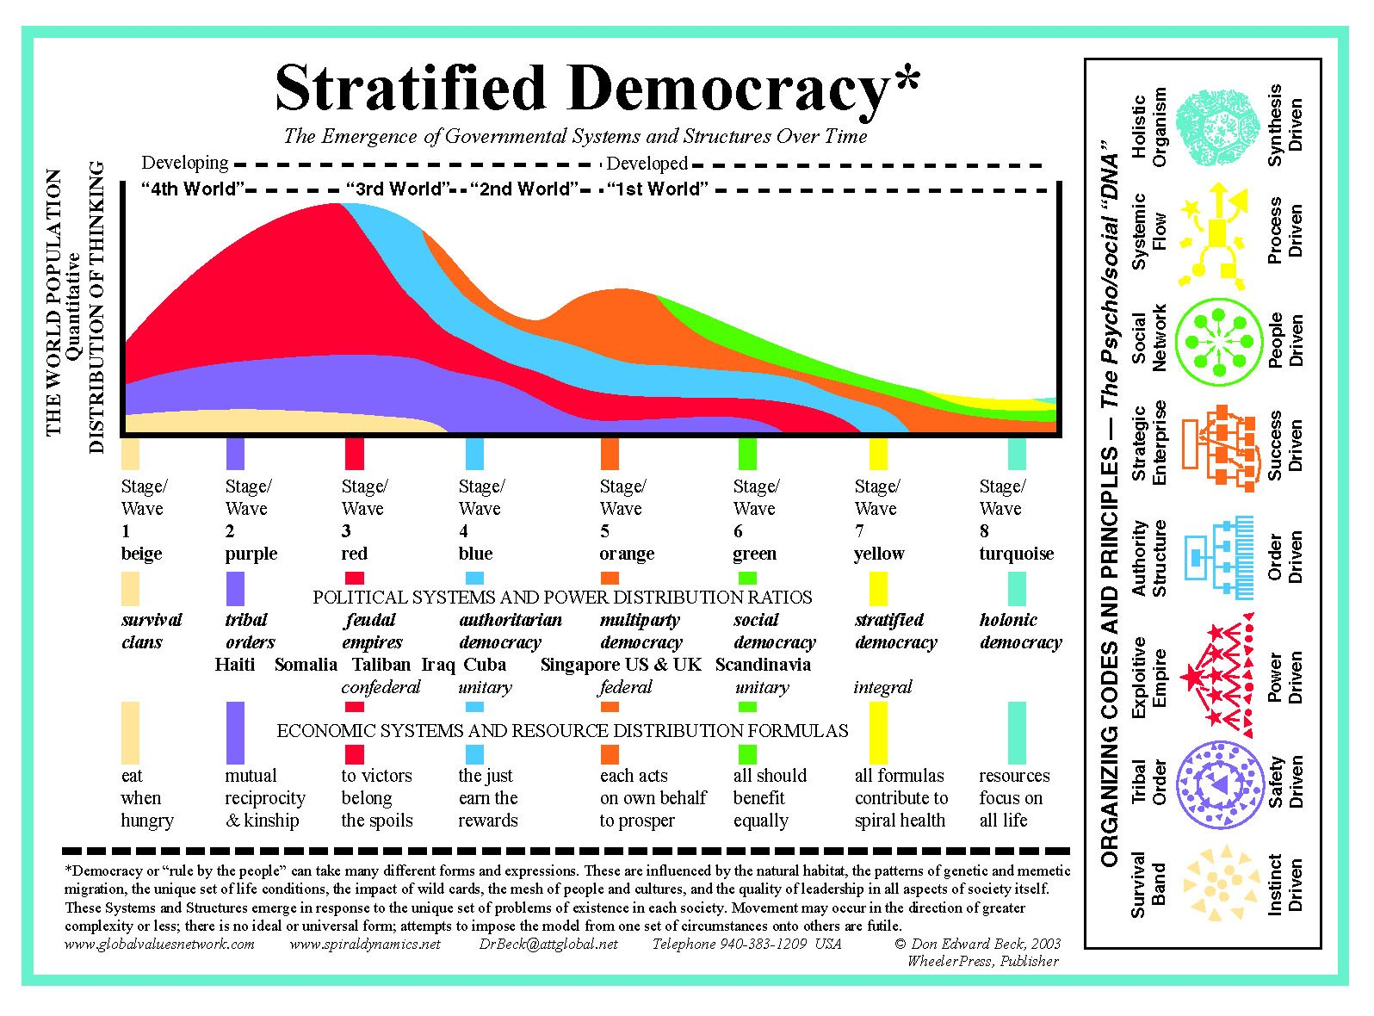
So, for example, the Enlightenment and Industrial Revolution, together with the scientific-rational mindset, emerged out of Orange (Corporate States) in response to the stifling control of the church and religion on the state (Blue - Ancient Nations), and its demand that we take things on faith, rather than through discovering the world ourselves by scientific exploration. This new thinking created tremendous opportunities for humanity, and brought with it the demand for individual rights. However, after some time of this system, we are now facing its limits. An uncontrolled expansion of enterprise, finance and business has led to the tragedy of the global commons, and a focus on a purely scientific reductionist approach has reduced morals, values and spirituality to secondary importance (if that). So new solutions emerge to deal with that problem (Green Value Communities and Yellow Integral Commons). The problem with most new stages of development like this is that they tend to throw the baby out with the bathwater - whereas what is needed is to transcend and include the old systems, remembering what problems it was initially designed to solve, taking with us the good bits, and leaving behind the rest.

The key point is that these are stages that emerge one out of the other - there is no jumping stages. Each emergent stage transcends and includes the previous ones. The stages are called Value Memes. Conflicts can arise between different surface manifestations of the same Value Meme (e.g. two Blue "one-truth" religions), or between manifestations of different Value Memes (e.g. Orange economic expansion vs. Blue protect-the-nation). What is important is to try to understand where a people or country is at in its development, support its current needs, and look for opportunities for it to move on when the time is right.

So let's look at how this map helps us to understand some of the dilemmas outlined above.

Liberalisation vs. Protection

The Liberalisation agenda tends to come out of the Orange perspective - it emphasises freedom, opportunity and individual achievement. Remove any barriers or borders that are in the way of people fulfilling their potential to achieve and become successful. This is the conventional centre of gravity of the industrialised world and the international financial institutions.

This comes under attack from two other perspectives. Blue takes a pre-conventional stance of needing to protect the heritage of the culture, the morals and traditions of the country and the nation state from the ravages of the encroaching free market. It responds to a need for order and stability, particularly in emerging nations where the national authorities are still "taming the tribes" in the rural areas to try and hold the country together. The last thing these countries need is a heavy dose of Orange throwing the gates open for a free-for-all, competitive race-to-the-top until there is enough Blue stability in place. Otherwise Orange opportunity will be hijacked by Red self-interest and narrow-minded fanaticism, creating chaos, disorder and internal strife.

Green, on the other hand, is also anti-conventional Orange, but from a very different perspective. Green sees how liberalisation has created large gaps between winners and losers, is concerned with how an economy of unlimited opportunity is damaging the environment, and wants to reign in the unbridled expansion of the market to respect the diversity of local conditions and avoid the imposition of a one-size-fits-all industrial model of development. However, what Green also has a problem with is Blue's authoritarianism, structure and strong need for order. It does not see a strong nation state as the answer, but rather diverse local communities, all flourishing peacefully alongside each other. As far as nation states are concerned, they should be adopting all the treaties of the United Nations, accepting international norms for human rights and environmental protection. This latter perspective is of course also anathema to many emerging nations who feel a need to focus on creating order in their own national backyard, without too much interference from others, unless it is to help them instill order.

The greatest pressure does indeed seem to be on emerging nations who are sensing Blue needs for order and stability, but are being forced to remove their boundaries and borders by an expansionist Orange, and are under attack from Green for not responding to the expressed needs of all the diverse "tribes" in their country that they are only just learning to hold together. On the other hand, Blue and Green are often perceived to be on the same side, as they are both anti-conventional Orange, but this is deceptive, due to the different deeper needs that lie behind each of their perspectives.

So, to look at some of the specific dilemmas outlined above. Mamadou Cissokho clearly represents the voice of a nation-state struggling to become one in its own right, feeling overpowered and ravaged by the power of the Orange liberalisation process. As he said himself, "we need more time to prepare". It is very important to listen to this voice, for if it is not heard, and a country like Senegal is not given the space and time to develop its own Blue order and national systems, creating the conditions for its people to develop a strong Blue foundation, then immense stress will be the result. If a people are confronted by an Orange system for which they are ill-prepared, the result is normally a regression into Red and Purple. This process was clear to observe in Russia, where Blue order was swept away, no time was given for new order to be established, and the free market and liberal democracy was introduced, leading to great tension and regression, manifesting in the emergence of a strong mafia, high levels of corruption and a huge divide between rich and poor.

Blue is an essential step for people. It introduces a sense of order and responsibility, and guilt for immoral behaviour. Both Orange free-marketeers and Green human rights activists will have to be a little patient, and allow people to take the steps they need to take, without denying them the very path that they themselves followed to get where they are. The key question to always ask is "from where, to where?" - it's simply about really meeting people where they are at.

Frederik Willem de Klerk and Ken Ash (deputy director for food, agriculture and fisheries at the OECD) were making a key point in the Trade and Agriculture workshop. The report phrased it in this way: "We agree that it is necessary to distinguish between different kinds of developing countries with different needs. Differentiated trade rules rather than one-size-fits-all solutions are necessary. The priority for developing countries is more market access, while for some of them it is also more protection of their domestic products." This is stratified thinking, which first asks where a people or country is at, understands the path of development, and then strives to design solutions which help with the next step.

It is important at this point to say that this is not a deterministic model of development on the surface level. The Spiral systems are deep codes, which manifest in multiple ways on the surface. The deep codes do seem to be universal, but they create huge diversity in their expression. So Orange achiever-self energy has created the free trade agenda as we know it now, but that is not the only possible expression of Orange. Orange is about enterprise, exploring, understanding, taking opportunities and trying to be the best at what one does. This could manifest in a different surface form to the one that currently dominates economic thinking. Likewise Blue's need for order and preservation of traditions does not have to result in oppressive dictatorships. It is more likely to do so if being threatened by other Value Meme systems such as Orange and Green. What is important is to keep in mind the deep codes and make sure that people have the opportunity to develop those in a healthy and supported way.

So for the liberalisation versus protection dilemma: first ask where a country is at, look into what deep Value Meme codes are active, and then design a stratified approach to trade that helps to meet countries and peoples where they are at, within a framework of global awareness.

That is likely to mean allowing some form of protected nation-building for some countries, with strong investment in the public and private sectors, protection from imports to allow the local economy and national identity to develop in a healthy way, and help to implement human rights and environmental norms in a way which supports the country's current phase.

For others, it will mean looking at how to gently start opening up and looking for the most effective way that country can graft a niche for itself in the field of international trade and relations - without undermining the diversity of the national and more local economies.

For those more mature industrialised nations, it means getting tougher on their global responsibilities, for example in the areas of environmental protection, international security (e.g. arms trading), and poverty reduction.

The challenge for those countries already ahead in their thinking about global responsibility (e.g. Scandinavia, Finland, Netherlands, Canada) lies in facilitating the emergence of a global framework that will protect Global Public Goods whilst allowing for the development of peoples, their communities and countries in a way best suited to them.

In this section, we have explored many of the principles of this thinking through the issue of trade. As we look at the next dilemmas, we won't be repeating the principles in as much detail.

Regulation vs. Own Responsibility

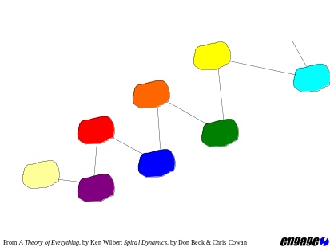There is an interesting dynamic at play in this dilemma. It is related to the two types of Value Meme that exist within the Spiral. You may have noticed that some of the colours used are warm colours (beige, red, orange, yellow) and some are cool colours (purple, blue, green, turquoise), and that they alternate up the Spiral.

The warm-colour systems are know as express-self systems, and emphasise I, and fitting the world to me. The cool-colour systems are know as sacrifice-self systems, and emphasise We, fitting myself in to the world.

Business, by its nature, tends to be about going out there, creating opportunities, selling one's product or service - very much an express-self energy. Governance, on the other hand, tends to be about ensuring that everyone fits in, and that there is not too much disturbance to the whole - more of a sacrifice-self energy.

Those arguing for a strong regulatory framework would be likely to be centred in a sacrifice-self system, probably Green, and those arguing for it to be left to their own responsibility would be likely to be centred in an express-self system, either orange or yellow. Orange would have a far greater aversion to regulation than yellow, which would give it serious consideration only if it thought it would be the most effective way of achieving the end result.

What often goes on in debates about regulation and responsibility, is that those who are more anti-regulation are seeing a Blue form of regulation which would be a one-size-fits-all encompassing and stifling system, and those who are more anti-leaving-it-to-your-own-responsibility are seeing more Orange self expression, which tends to be fairly self-interested, rather than interested in the well-being of the whole. Pro-regulation would argue (from their experience of Orange) that you cannot leave it to people to regulate themselves as ultimately they are only in it for themselves. Anti-regulation would argue (from their experience of Blue) that people who make rules are only in it for their own power, and (from their experience of Green) that they only make rules that reflect their ideology, not the way things are on the ground. This creates large amounts of mistrust and can stifle possible co-operation.

What is actually opening up now is the possibility of coming up with a combination of regulation from a Turquoise perspective and responsibility from a Yellow perspective, both of which would be concerned with the well-being of the whole and all its parts.

The task is therefore to take the debate beyond worst expectations, and explore the potential of more enlightened regulation and responsibility that can blend together to best serve the collective purpose. Regulation should not stifle possibilities for taking responsibility oneself, and responsibility should not be an excuse to avoid taking the action that is necessary to protect the interest of the whole.

This possibility was beginning to emerge in the workshop on TNCs: Sustainability, Accountability and Partnership. Erik Jonnaert (Procter and Gamble) accepted that some form of regulation was important, particularly as it would support organisations that were trying to practise corporate social responsibility and protect them from free-riders exploiting their goodwill, in conditions where people and planet didn't create more profit. He wanted Governments to take responsibility for this, as they are the bodies with democratic legitimacy. Lord Holme (an advisor to Rio Tinto) was strong on the need for regulation around transparency and democratic legitimacy.

It would benefit the NGOs to start asking how regulation and accountability mechanisms could support TNCs in their CSR efforts, rather than radiating a suspicion about their intents. There is no doubt that both are needed, the question we need to be asking is how can regulation best empower us to fulfil our responsibility?

Industrialisation vs. environment

We touched on this in the liberalisation vs. protection analysis. There is an important element to add here. Each emergent system transcends and includes the previous systems (as illustrated in this graphic of the Spiral, where the higher systems also include the lower colours). They therefore increase in complexity and breadth of vision. The general trend is ego-centric > ethno-centric > world-centric.

An implication of this is that those with world-centric perspectives have a responsibility to look after the bigger planetary space that they are aware of and concerned about. That means that whilst creating the conditions for developing nations to industrialise and take advantage of the opportunities which that brings, they have to try and create a framework which protects the environment and global values of peace, justice and sustainability within which that development can happen. On the one hand, it is important not to deny peoples and societies their journey through the deep codes of the Spiral (in whatever surface form that takes), and on the other hand it is important to take responsibility for the world-centric perspective that one has, in order to create a healthy planet for all.

In a practical sense, this could see the emergence of Orange enterprise, business and opportunities not in the form of polluting industries like we saw in the Industrial Revolution, but in the form of sustainable technologies and exploration into ways we can most effectively live together as humans in the coming years.

Valuing Global Public Goods vs. Skepticism of the Market

This dilemma is often dominated by Green hostility to the competitive market as it has experienced it in Orange. The question of giving value to Global Public Goods is a complex question which demands thinking beyond Green. Aligned behind a common purpose of valuing the Global Public Goods as highly as they deserve to be valued, we must explore how to make that happen - letting go of past prejudices whilst learning from past limitations. Maybe the market does have a role to play, but that would only be within a Yellow design where it is aligned with the good of the planet and not with people's or organisations' self-interest.

The Dynamics of Change

Some of the dilemmas outlined above can be unmasked by understanding the natural dynamics of change that are at work (Beck and Cowan, 1996). Elements of this are:
- Change states - understanding where one is at in the process of change
- Change conditions - what conditions need to be in place for certain types of change to occur
- Change Variations - what different types of change are appropriate in different contexts
Any new approach to global problem-solving will have to take these elements into account when working with the relevant stakeholders.

Change States

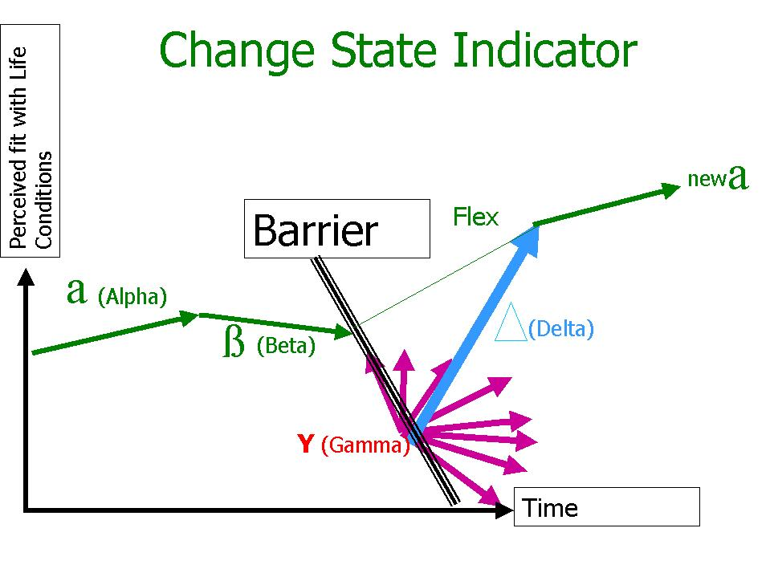
The graphic represents a simple illustration of a change process. In the Alpha state, everything is fine - the way we understand the world fits with the world we experience around us. In the Beta state, that fit begins to get stretched, as we begin to find it harder to make sense of the world around us. At that point, we either manage to adapt to the new reality, and flex up to the next Alpha fit, or the Beta intensifies, to the point that we seem to hit some barriers, and dive into the Gamma trap. In the Gamma trap we expend a lot of energy fighting to work it all out, fighting an old system, either in ourselves or outside of us. Usually, we break through the barriers, resulting in the Delta surge up to the new Alpha fit. The Delta surge is a place of high energy and excitement - the risk is that in that period one cuts the head of the old order which has held us back for so long.

A key element in change processes is the need to transcend and include the old. When that happens in a healthy way, what was there before is not denied (as it emerged initially in response to old problems), but is refined and the best of it taken forward in to the new. What often happens, particularly after a heavy Gamma trap, is that one transcends and represses the old - which results in pathologies later down the line. Underlying this thinking is a picture of change as an evolutionary process, within which one solves a certain set of problems that have arisen (creating a new Alpha state), and in doing so one is sowing the seeds for the next set of problems. When those begin to manifest (Beta), one has to develop new solutions, transcending and including the old. And it just goes on like that - we think we've got to the top, when the next summit comes into view. As Albert Einstein said, "no problem can be solved with the same thinking that created it".

Change Conditions

There are many theories about change. This one synthesises various approaches, in identifying what conditions need to be present for change to take place. They are:

- Solutions to previous existence problems exist, creating energy for exploration / change. If one is just entering a new Alpha phase, solving the problems which triggered it, then one is not likely to be ready for another challenge and change. The old problems need to be solved first.
- Dissonance exists with the present system / condition, and triggers search for solutions to deal with it.
- Barriers to change are identified and overcome. One has a picture of what is stopping the movement from here to there, and is working on the blockages. Those can be exterior systemic barriers, or they could be interior blocks, such as limiting belief systems.
- Insight exists into probable causes of the problems and potential alternatives. It's important to see a possible future. Visioning work is useful here.
- Consolidation measures exist to support the change process. If there are no systems in place to support the new way of being, then it will not survive.

Change Variations

There are different types and intensities of change. They are related to the Change Conditions above, in the sense that the type of change that is relevant depends on how many of the conditions are met. Here, we will look at three main types of change: horizontal, oblique, and vertical.

Horizontal change is the least intense form of change, where the current system gets an upgrade, without changing the whole system. The way things work at the moment is re-arranged to help the current system work more effectively.

Oblique change is where there is at least some dissonance, and some of the barriers have been identified. Oblique change can involve regressing back to old ways of doing things, in order to gather energy from those earlier systems for the change ahead. It can also involve stretching up to a new way of doing things, without completely changing to a new system. In both situations, they are stretches from the current status-quo, which inform and refine the current system more radically than horizontal change.

Vertical change is where a whole new system, way of doing things, emerges. For this to happen, all of the change conditions need to be in place. The old system is transcended and included, and the new one looks and feels very different.

With these three elements of the change dynamics in mind (change states, change conditions and change variations), we can explore some more of the dilemmas that appeared during the conference.

Old vs. New

The essence of this point was the revolution or reform debate, with some arguing the old structures had to be done away with, and others arguing for them to be worked with.

On the one hand, it is clear that current methods for global problem solving are inadequate to the complexity of the problems we are facing - they will not deliver solutions quickly enough, as they were designed to deal with another reality initially, not the emerging one. So we will not successfully respond to today's Betas and Gammas with an old Alpha - it will have to be a new system. The question is how to get there.

Those who argue for a Delta surge style revolution run the risk of transcending and repressing, rather than including. It is the difference between differentiation, which is essential for any process of change, and disassociation, where one breaks completely from the past.

We need to be working on the insight change condition to get some vision of how things could be. This should then serve us to move from where we are now to the next step, by integrating the best from the past. What is important is to remember why the current systems were developed in the first place, what problems they were responding to, and making sure that we don't throw the baby out with the bathwater.

It is normal that those who are seeing the world from a post-conventional perspective are demanding radical change, and can sense what it needs to be. However, it is essential to move from where we are, remembering where that is and why we are there. That doesn't mean it has to be done slowly, but it does mean that it has to be done from a developmental perspective.

Those who have vision and insight of how things could be, need to get together with those who have a good understanding of and relationship with current systems, but are feeling dissonance with it themselves, and start exploring the question "from where to where?" and how. They need to find common purpose, and keep focused on that, rather than on their personal agendas. How can we work this out together for the common good, deeply understanding our different perspectives and how they relate to each other?

In terms of the change conditions, many are in place, but not everyone is aware of them. The current systems have solved the problems they emerged to solve in the first place - offering people more choice in a market-led society than a church-state run society, and the ability to develop their individual capacities. This emerged initially of course in the now industrialised countries. Although it has also liberated some in less industrialised countries, one of the problems it has created is that of exclusion and extreme gaps between rich and poor. There is certainly dissonance with the way things are, which is feeding must of the stress and fear that is around at the moment. Much insight exists around the causes of the problems and lots of ideas around alternative ways of organising ourselves. The real barriers to change have not yet been widely understood, and the consolidation measures are not in place, so these two change conditions need attention before we can get the vertical change that is necessary to deal with the new life conditions we are sensing.

Dialogue vs. Impact

The essence of this is the increasing discussion of the problems and therefore increasing awareness, versus the seemingly insignificant impact.

This is to do with the rise of the dissonance change condition, and the building sense of Beta stress. Our global system is feeding itself stress signals and increasing the dissonance felt. The reason that not much seems to have been done about it, is that the other change conditions are not yet in place, particularly around barriers and consolidation. This is a tension which will push people to seek further insight, and identify the deeper barriers. In the meantime, frustration is the order of the day - increasing dissonance and awareness of the problem, and no concrete solutions manifesting yet. The speed at which we manage to overcome the barriers will determine how intense the Beta and Gamma stages are.

Need for global problem-solving fora vs. current power imbalances

The problem here is that the global space is one which was first explored by industrialised countries, on their colonial trips and since then in international trade. They therefore dominate this space with their power and experience. At the same time, it is in the global space that we need to work to address intrinsically global issues. Given that the old powers dominate that space and the institutions governing it, it is no surprise that less industrialised world is suspicious of those institutions. Multilateral processes must be containers for stratified thinking, not one-size-fits-all solutions.

In order to move forward on this, the two sides each need to make an important step. Firstly, the industrialised world needs to accept that if they are going to work on intrinsically global issues, then they must make sure that the processes they use reflect the make-up of that space. All countries and peoples must feel that they are being heard and responded to adequately. This will require some redistribution in terms of who picks up the tab for the use of Global Public Goods. In lengthening the time perspective, it is clear to see that the cost of the rich countries not addressing this problem will be far greater than preventative action now.

Secondly, the less industrialised world needs to accept that industrialised countries do have more experience in the global space, and that that experience could be used for the well-being of everyone.

Then it all needs to be framed in a deep developmental perspective, like the Spiral - sensitively, and in a way that all sides can see how their needs can be met, whilst accepting the need for the Global Public Goods to be protected and nurtured for the good of everyone. Global standards which are developed must be applied appropriately across the board, and all must be seen to be doing their bit.

National Identity vs. Transnational Governance

This is going to be key. In terms of change dynamics, the transcend and include principle is of relevance here. As transnational forms of co-operation emerge, they must allow space for the healthy existence of nation states, and the development of those states based on where they are at.

In terms of emerging or re-emerging states, they are still working on the existential problems related to their own national identity and systems. Until they are comfortable with those, they are likely to remain largely hostile to any proposals that look like they are being told what to do by a higher power.

Global systems have to support healthy nations. One of the biggest problems at the moment is that nations are being put under stress by unregulated action in the transnational sphere. Global systems of co-operation could release nations (and more local communities) to do that which they are good at, whilst demanding their responsibility for the global space of which they are a part - proper subsidiarity. They are not mutually exclusive, but in fact have to be mutually reinforcing.

Promises vs. Implementation

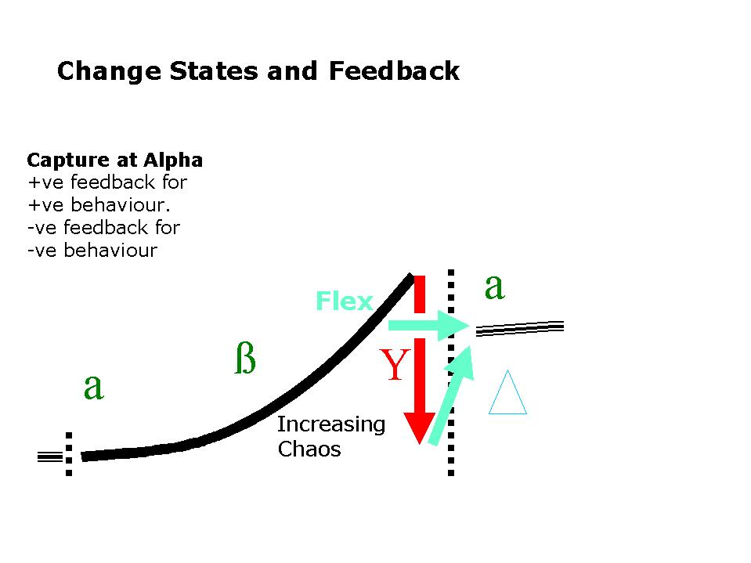
One of the key elements of a new system is ensuring a "capture" system in the new space to ensure that the actions of the parts are in the interest of the whole, and that any free-riding is captured and fed back to the free-rider.

At the moment, that capture system of external management does not exist in the global sphere. This means that global co-operation relies on internal management by the parts - in this case nation states. Currently only a few see it as in their interest to make the financial commitments to back up global promises and initiatives. At the moment, the rest can free-ride on the generosity of the few.

Given the different stages of development of countries across the planet, this is likely to remain the case. Hence the need to shift from purely internal management, to more explicit external management of the global space, in the interest of all the parts and the greater whole. It will be the job of those who lead this change to illustrate to all nations how it is in their interest, given where they are at in their development.

One reason that that system is not emerging already is a lack of Coalesced Authority Power and Influence (CAPI) (from the work of Ichak Adizes, see www.adizes.com). As Herfkens pointed out, the good intentions of development or environment ministries are often stifled by the finance ministries. They are the ministries which hold a large part of the Power, so it is essential to have them round the table and backing any deals.

Taking it Forward

"The challenge of global democracy is one of finding instruments and institutions that will equally protect globally shared values and local differences"
(Forum 2000 Declaration 2001)

"If I consider my own political impatience, I realise with new urgency that a politician of the present and the future must learn, in the deepest and best sense of the word, the importance of waiting. I don't mean waiting for Godot; their waiting must be the expression of respect for the inner dynamics and tempo of Being, for the nature of things, for their integrity and their independent dynamics, which resist coercive manipulation. They must have the will to open events to the possibility of manifesting ourselves as they really are, in their essence" (Vaclav Havel)

In this section, we build on the unmasking above, to outline three main areas of recommendations for the future: the space, the perspective and the focus.

The space

If we are to gather the people together who hold power, authority and influence in order to successfully address the intrinsically global problems we are facing today, the container within which the conversations happen is going to be essential.

The space created by the container must be one in which there is a focus on a collective purpose, where the individuals present leave their representative hats behind, and meet as world citizens. Rischard (2002) describes this well:

There must be discipline in this. Parties that come merely to state their position but aren't willing or able to engage in the open-minded brainstorming and exploration of options required for global problem-solving would dial themselves out. … A member may have come in as business, government or civil society representative, but once in, must think and act as a global citizen, not as a staunch defender of a narrow interest. (174)

There must be a set of principles to make this clear which participants agree to in accepting to participate, and those principles must be strongly enforced by the facilitators.

The role of the facilitator is essential. They must be people with strong integrity, who are able to hold the boundaries of the container strongly in order to keep the focus on the collective purpose. They need not be experts on the topic, although some insight would be useful. They should not be perceived as biased on the topic by any of the parties. The most important issue is their ability to hold a space which helps people to stay beyond their personal agenda and working together to create solutions.

When this focus is achieved, the energy which connects up a group goes to work, and they come up with solutions which no one member on their own could ever have come up with - the whole becomes greater than the sum of the parts. It is an inspiring space to work in, and remarkable things happen.

The common, collective purpose is also essential. A group can be held together by this kind of super-ordinate goal, when they all feel really committed to it. It is what makes the group more than just the parts, and keeps the collective energetic focus. Dee Hock, founder and CEO of Visa International, and author of "The Birth of the Chaordic Age", defines it as "a clear, unambiguous expression of that which we jointly want to become". I sometimes replace "become" with "achieve", depending on the context.

Principles then help the group to agree on how they are going to reach their purpose. They frame the space, and must be meaningful for all participants. As mentioned above, the organisers need to be clear on the purpose and principles of their own container first, as that is the process which they are inviting people into.

The space must also reflect the stakeholders in the topic. As such, people should be present from business, governance structures and civil society, and also representative of the different deep emergent needs from across the planet. However, whichever sector or region they come from, the primary condition is that they are willing to be there as a world citizen.

The Perspective

The perspective within which global problem-solving is framed is also essential. This perspective should be of the quality that de Klerk was bringing to the Trade workshop. I would call it an "integral" perspective. This would include:
- a developmental stratified understanding of global issues (as outlined with the Spiral above)
- taking into account both exterior perspectives (e.g. facts and figures) and interior perspectives (e.g. senses of power relationships, deep value systems)
- natural change dynamics

An "integral" perspective makes space for all perspectives on an issue, and then relates them to each other in a framework which is conscious of developmental differentiation, and the different needs that are present as a result. It makes sure that any solution takes into account all the perspectives, and meets the needs of all the parties, whilst safeguarding the space of the whole.

The analysis in the second section above attempts to use this perspective to show how one can transcend current dilemmas by locating them in such an integral framework. The key is to locate the deep needs related to the Value Meme codes, and then to facilitate the design of policies which meet that need within the bigger planetary context.

Its "Prime Directive" is to understand where people are at, and to design systems that meet them there. Key questions are "from where to where?", and "how should who govern whom to do what?" (from Don Beck). This is the spirit behind the two Havel quotes used above.

Ken Wilber (2000) sums it up:

We are awaiting the new global founding Fathers and Mothers who will frame an integral system of governance that will call us to our more encompassing future, that will act as a gentle pacer of transformation for the entire spiral of human development, honouring each and every wave as it unfolds, yet kindly inviting each and all to even greater depth.

The Focus

This looks at what the content could be that fills the space within this integral perspective.

Firstly, I think it would be useful to have people contributing to the conference who are experts on change. The problems are not so much about identifying what the issues are anymore, but about how we move from here forward. Given the speed with which things are changing today, we cannot plan too far in advance, so there is no point in coming up with a set of policies for ten years down the line. We must make an assessment of where we are at, and with a guiding intent, work out the next step - then implement it, stop, sense and act again.

Secondly, the change conditions which need work (based on the analysis above) are identifying and overcoming barriers to change, and developing consolidation structures to support the change as it happens. It would be useful to give a clear focus around what the barriers are which are preventing the change from happening, and how might we start to overcome them. An exploration of what support structures might look like would also be a valuable contribution at this time. Part of this process could be to look for the intelligences that are emerging in contexts of similar complexity, to see what kind of solutions are developing and how we might learn from them.

Thirdly, it would be useful to focus on some of the intrinsically global issues separately, under the kind of conditions described by Rischard (2002). The space would need to be framed as above. He notes the importance of including people from government, business and civil-society, and suggests each issue-based stream (or Global Issues Network, as he calls them) is hosted by one of the multilateral institutions (e.g. the appropriate UN body). Another condition for the people participating is that they are truly experts in the issue, not just PR people from TNCs, generalist civil servants or NGO campaigners - they must know their stuff and have a passion for the topic.

This third point would tie in with a suggestion which emerged from the Global Public Goods workshop for some kind of Forum on GPGs to take the work forward. The next conference could be a starting point for some of the Global Issues Networks on a few chosen topics related to GPGs, where we set up the container, and start what Rischard calls the "constitutional" phase. They could then continue their work afterwards, potentially along the lines Rischard suggests (norm-producing phase, to implementation phase) or along some other path which has been evaluated as being potentially more effective. They could be revisited at each annual conference, with work being done for the appropriate stage that they were at.

Conclusion

Listen to Vaclav Havel's call for patience and an understanding of the natural unfolding of human affairs. Reframe global issues from that kind of integral, evolutionary perspective. Create the space that will hold collective purpose and take people beyond their own agendas. Focus on understanding the dynamics of change. Help the world to take the next step from where we are currently at on the key issues we are facing - then stop, sense again, listen deeply and boldly take the next step.

Peter Merry is a Human Ecologist and parent. He is co-founder of Engage! InterAct (www.engage.nu/interact), and is a Fellow of the Centre for Human Ecology (www.che.ac.uk). He lives in the Hague, Netherlands, with his wife Marcella and son Finnlo.

Bibliography

Beck, D (2001), The Global Great Divide, Institute for Values and Culture, Texas.

Beck and Cowan (1996). Spiral Dynamics, Blackwell, Oxford.

Rischard, J-F (2002). High Noon - 20 Global Problems, 20 Years to Solve Them, Basic Books, New York.

Wilber, K (2000). A Theory of Everything, Gateway, Dublin.

Wilber, K (2000). Integral Psychology, Shambhala Publications, Boston.

Wilber, K (1981). Up from Eden, Theosophical Publishing House, Wheaton.

Spiral / Earth cover graphic and Stratified Democracy graphic
used with kind permission of Dr Don Beck.

"Inherently Global Issues" is a term coined by Jean-Francois Rischard, the World Bank's vice-president for Europe, in his book "High Noon". He defines them as those issues which are "insoluble outside a framework of global collective action involving all nations of the world". He divides them into three groups: 1. Sharing our Planet - Issues involving the Global Commons, 2. Sharing our Humanity - Issues requiring a global commitment, 3. Sharing our rule book - Issues needing a global regulatory approach.
Developed by Dr Don Beck - see www.spiraldynamicsgroup.com
See Integral Psychology and Up from Eden by Ken Wilber. In Integral Psychology you can see various maps side-by-side, and Up from Eden makes references to many sources which are describing the same process of development.
Used with kind permission of Dr Don Beck.
There are of course always a diversity of Value Memes active in an individual, amongst one people or in one country, but there tends to be a centre of gravity, which can be seen in the norms of a group and the structures its creates. These would reflect the conventional way of doing things. If you are at an earlier place, you will be seen as pre-conventional and educated to become conventional. If you have transcended the conventional centre of a group, you will be post-conventional, maybe a bit of an idealist or a threat to the stability of the status quo. The group will hold you back if you try to go too far.
One of the important elements of this developmental model is the major shift that happens after the sixth system, Green. The first six systems are known as 1st Tier and the next six as 2nd Tier. The major difference between 1st and 2nd Tier systems is that 1st Tier systems can only see their own perspective as being the right one, and so will do what they can to fight other Value Meme perspectives, whereas 2nd Tier systems can see how the different perspectives fit together and are in fact dependent on each other functioning in a healthy way.

